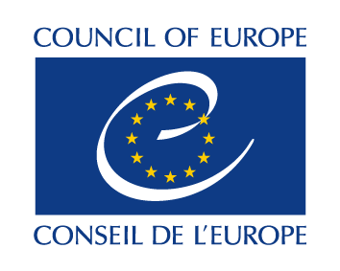
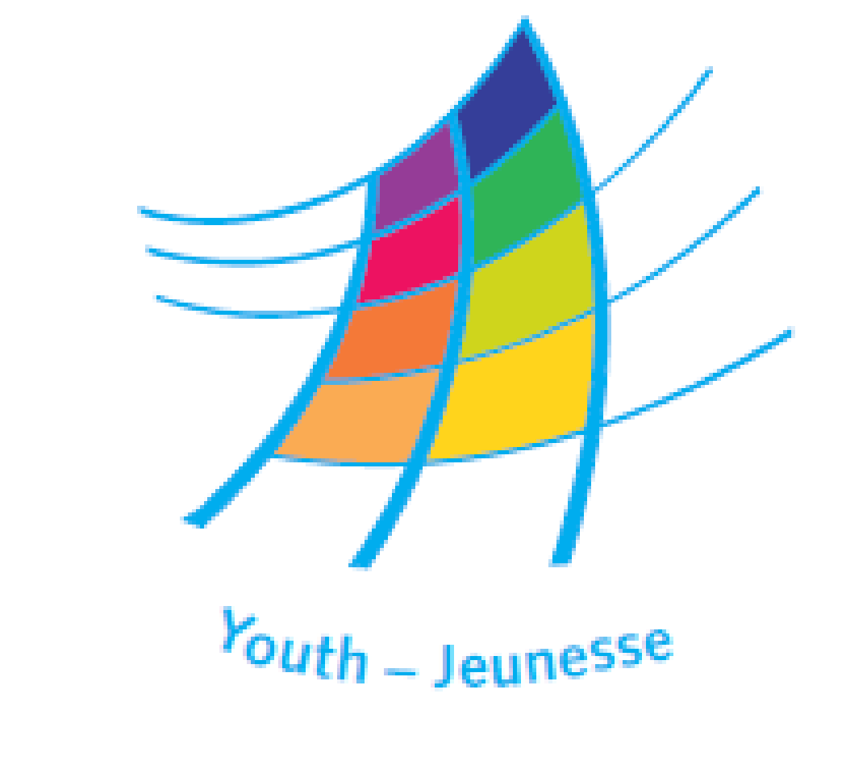

DDP-YD/ETD(2020) 23 14 February 2020, Strasbourg

Trainers’ Pool

The Trainers Pool of the Youth Department of the Council of Europe is composed of trainers and educational experts experienced in intercultural learning and non-formal education applied to international youth work activities.
The trainers are active in the implementation of the youth programme of the Council of Europe and contribute to sustain and development its education and training activities

Procedure and
Application Form

For trainers interested in joining the pool

PROCEDURE

The procedure for admission in the Trainers’ Pool comprises 3 major steps:
- Candidate trainers fill in the form below and send it to the secretariat of the Youth Department of the Council of Europe, together with at least 2 letters of recommendation and a recent curriculum vitae)
- The secretariat of the Youth Department assesses the application and communicates its decision to the applicants
- If accepted, the applicants fill in their profile in the Trainers’ Pool on-line database and undertake a self-assessment form.

APPLICATION FORM

- First name(s) and surname(s):
- Sex:
- Nationality/ies:
- Country/ies of residence:
Optional:
Internet homepage(s) (if applicable):
Salto TOY page (if applicable):
EKCYP (if applicable):

- Working languages - please indicate all your working languages (including your mother tongue(s):

- Trainers’ competences - please provide concise information allowing the secretariat of the Council of Europe to assess your compliance with the following requirements applying to the profile of a junior trainer (see also the document “Competences for YD external junior trainers”:

- Experience as a trainer and/or member of a team of trainers in international and intercultural youth work activities.

- The ability to contribute constructively to and assist in the preparation, running and evaluation of the activity, based on intercultural non-formal education.

- The ability to run parts of the activity independently (such as selected workshops, working groups or similar programme elements).

- Good knowledge and experience of youth work in at least 3 of the following domains:
- Human rights education and education for democratic citizenship
- Youth participation, democratic citizenship and the development of youth work and youth organisations
- Promoting gender equality through youth policy and youth work
- Environment and sustainable development
- Intercultural youth work in a multicultural environment
- Promoting responses to racism, intolerance and discrimination
- Youth work for peace-building, conflict prevention and transformation
- Promoting global solidarity and cooperation
- Youth information and counselling
- Promoting access of young people to social rights
- Non-formal education/learning as a means of facilitating the social inclusion of young people and children
- Promoting intergenerational dialogue and solidarity
- Supporting youth and child policy development at national level
- Using e-learning in non-formal education activities
- Using information and communication technology in youth work

- The ability and willingness to work in an intercultural team.

- Intercultural competence, especially in respect to working with multicultural groups. The trainer is aware of own biases, understands and applies tolerance of ambiguity and has capacity to take distance to social roles.

- Good communication skills (including active listening and ability to address conflicts positively).

- Self-evaluation and self-development (the trainer is a self-directed learner; is willing to constantly develop his/her competencies).

- Sense of responsibility for one’s own actions, a commitment to personal development and social change.

- Youth work experience. Since when –and where / how - have you been involved with

- grassroots youth work?...

- international youth work?...

- Which training courses for trainers have you attended as participant (please provide details about the organisers, duration of the course, trainers in the course, and indicate the competences addressed by the training for trainers)?:

- Your comments about the values and approaches of the Council of Europe in non-formal education and training youth activities:

Please append to this application:
Letters of recommendation from at least 2 trainers, of which at least one should be a current member of the Trainers Pool and, if possible, one has been a trainer in an activity where the applicant was participants;
- An updated curriculum vitae.

And send everything to youth.trainers@coe.int

If accepted for membership of the trainers pool, you’ll receive the a registration key from the secretariat and be invited to fill in your profile on-line and your self-evaluation form.

Working languages should be understood as languages in which the trainer is to work in a training activity; it includes basic reading and writing skills.
See also the document “Guidelines for recommendation letters for new TP members”

